Electronic Components

- Flight Controller
1.1) Introduction:
The flight controller is the central processing unit of a drone. A small box filled with intelligent electronics and software, which monitors and controls the drone. It’s a circuit board equipped with sensors that detect the drone’s movements and user commands. With this information, the FC adjusts the speed of the motors to move the drone in the desired direction.
All flight controllers have basic sensors like gyroscope and accelerometer, while some even include optional sensors such as barometric pressure sensors (barometer) and compasses (magnetometer) to aid in autonomous flights.

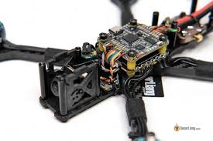

1.2) What does a flight controller for drones do?
A flight controller does can be classified within one of three categories: Sensing, controlling, and communicating.
1.2.1) Perception (sensing):
The flight controller is connected to a set of sensors. These sensors give the flight controller information about like its height, orientation, and speed. Common sensors include an Inertial Measurement Unit (IMU) for determining the angular speed and acceleration, a barometer for the height, and distance sensors for detecting obstacles. Just like how we perceive as humans, the drone filters a lot of this information and fuses some to get more efficient and precise information. Advanced flight controllers can sense more precisely and detect differences more quickly.
1.2.2) Controlling:
A flight controller controls the motion of the drone. The drone can rotate and accelerate by creating speed differences between each of its four motors. The flight controller uses the data gathered by the sensors to calculate the desired speed for each of the four motors. The flight controller sends this desired speed to the Electronic Speed Controllers (ESC’s), which translates this desired speed into a signal that the motors can understand.
Calculating the movements, fusing and filtering the sensory information, and estimating the safety and durability of a flight is all done by an algorithm. The most commonly used flight control algorithm is called PID control: Proportional Integral Derivative control. Within this area, there is a lot of research going on, which resulted in INDI: Incremental Nonlinear Dynamic Inversion. This algorithm reads out and reacts to incoming information way faster, therefore making the drone flight more stable.
1.2.3) Communicating:
A key part of a flight controller is communication. A part of the sensor’s job is to give out information that needs to be translated clearly for a pilot to read, which means efficiently. An obvious thing to communicate is its battery level, which can decide if a pilot wants to fly further or return to the charge.
But communication goes further than from flight controller to human pilot; with the entrance of auto-pilot programs in the drone industry, flight controllers need to communicate with other computer systems about its flight destination and how to get there. Communication is mostly done with wi-fi and radio frequencies, but cellular solutions are also already in use.

1.3) Flight Controller Types:
Plane/Wing Oriented FC
AIO FC (1 board)
Regular FC/ESC Stack (2 boards)
Multirotor Oriented FC/ESC Stack
Flight Controller

1.4) Core responsibilities of a flight controller include:
1.4.1) Stabilizing flight:
Using gyroscopes and accelerometers, the FC ensures the drone remains balanced and level during flight.
1.4.2) Processing input commands:
It interprets commands from the remote control or autopilot system and adjusts the drone’s motors accordingly.
1.4.3) Navigation:
Some flight controllers incorporate GPS for autonomous navigation and return-to-home functionality.
1.4.4) Data integration:
They communicate with external systems such as cameras, payloads, or telemetry modules.
Flight controllers often run on specialized firmware like Betaflight, ArduPilot, or PX4, which enable features ranging from basic stability to advanced autonomous flight.

1.5) Application:
1.5.1) Stabilization and Altitude Control:
The primary function of a flight controller is to stabilize the drone during flight. It continuously adjusts motor speeds to maintain balance.
1.5.2) Autonomous navigation & Way point tracking:
Flight controllers enable autonomous flight by integrating GPS, IMU, and compass data. They execute predefined flight paths or waypoint missions without manual control. Used in mapping, surveying, and agricultural missions where drones must cover large areas systematically.
1.5.3) Stabilized Camera and Payload Control:
Many flight controllers manage gimbals and camera stabilization systems. They ensure smooth, vibration-free footage even in turbulent flight conditions. Also handle payload release mechanisms (e.g., seed dropping, delivery drones).
1.5.4) Obstacle Avoidance and Collision Prevention:
Flight controllers integrate with sensors such as LiDAR, ultrasonic sensors, or computer vision systems. They process real time environment data to avoid obstacles and ensure safe path.

1.6) Advantages:
1.6.1) Stable Flight:
The flight controller keeps the drone balanced and steady in the air. It automatically adjusts the speed of each motor.
1.6.2) Autonomous Flight:
The flight controller can guide the drone automatically using GPS and sensors.
1.6.3) Real Time Data Monitoring:
It collects and sends data like altitude, speed, battery, and GPS position to the pilot or ground station.

1.7) Limitation:
1.7.1) High Dependence on Sensors:
Flight controllers rely heavily on sensors like GPS, IMU, and barometers. If any of the sensors give wrong data it will crash or become unstable.
1.7.2) Cost and Maintenance:
Advanced controllers with GPS, LiDAR, and AI support are very expensive. They also require frequent maintenance.

- ELECTRONIC Speed Controller

  - Introduction:
An ESC, or Electronic Speed Controller, is responsible for controlling the speed of motors in a drone. The ESC receives throttle signals from the flight controller and drives the brushless motor at the desired speed. Using high-quality ESCs leads to a reliable and smooth flight experience.

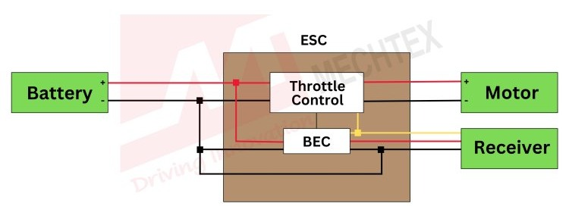

  - How does it work:
The role of the ESC is to act as the regulating middleman between the battery and the electric motor. It controls the rotation of the motor by delivering timed electric signals that are translated into changes in speed.
It uses the direct current from the battery coupled with a switch system to achieve an alternating three-phase current that is sent to the motor. The vehicle’s flight controller is used to vary the speed of the motor. Increasing the throttle increases the output power, which modifies the rate at which the switches open and close in the ESC’s circuit.
There are several signal delivery protocols that are used to convey throttle information from the remote controller to the ESC. Each protocol has a slightly different performance, the most common ones being PWM, Oneshot, Multishot and Dshot.

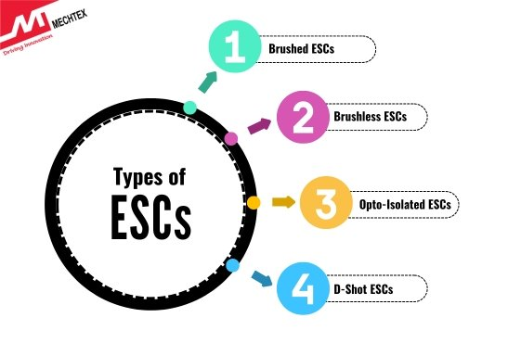

  - ESC Components:
Within the ESC there are a number of important components, including the microcontroller, gate driver and MOSFETs , as well as the battery eliminator circuit and device manager adapter in some cases.
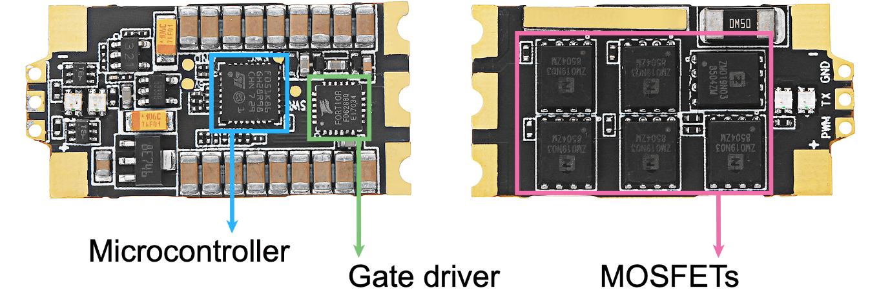

  - Applications of electronic speed controller in drones:
2.4.1) Motor Speed Regulation:
The primary function of an ESC is to control the rotational speed (RPM) of motors used in drones.
2.4.2) Thrust and Lift Management:
By varying motor speeds individually, ESCs help control drone altitude and direction.
2.4.3) Power Conversion and Protection:
ESC’s convert the battery’s DC voltage to three-phase AC signals required by motors.
2.4.4) Communication with Flight Controller:
ESC’s as a communication bridge between the flight controller and the motor.

  - Limitations:
2.5.1) ESC Not Powering Up:
One of the most basic problems is that the ESC doesn’t power on or fails to initialize. This issue can manifest as a lack of response from the motor.
2.5.2) Motor Stuttering or Not Spindling:
If motor fails to spin or only stutters without fully starting, the ESC may be failing to deliver power correctly or is struggling with signal interpretation.

2.5.3) Overheating ESC:
Overheating is a common issue, especially in high-performance applications like drones. If the ESC gets too hot, it may trigger thermal protection, causing the motor to stop or slow down.
2.5.4) ESC Reboots Mid-Flight or During Operation:
If ESC restarts or cuts out during operation, it can lead to erratic motor behaviour, causing the drone or vehicle to lose power or crash.

- Global Positioning System Drones:

3.1) Introduction:
The Global Positioning System (GPS) is a navigation system using satellites, a receiver and algorithms to synchronize location, velocity and time data for air, sea and land travel.

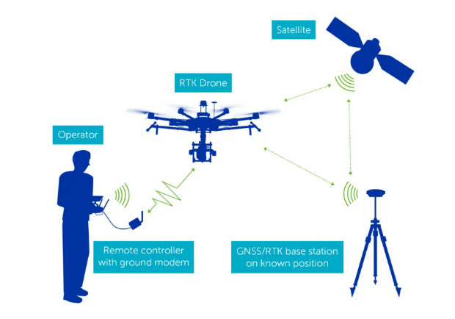
3.2) How do GPS Drones Work?
The working principle behind drones and GPS integration involves calculating a drone’s exact location by receiving signals from different satellites in the GPS constellation. The drone’s GPS module interprets these signals to determine latitude, longitude, altitude, and speed in real-time. Advanced drones may also support multi-constellation GNSS (Global Navigation Satellite System), enhancing positional reliability in obstructed or remote terrains.
The true power of GPS drones is unlocked when this positional data is fed into onboard navigation algorithms, enabling precision-controlled flight paths, flight automation, and seamless geospatial data capture.

3.3) Types of GPS Drones:
    - Multi-Rotor GPS Drones.
    - Fixed-Wing GPS Drones.
    - Hybrid VTOL (Vertical Take-Off and Landing) GPS Drones.

3.4) Key Features of GPS Drones:
3.4.1) Autonomous Flight & Waypoint Navigation:
GPS integration allows pre-defined route planning and autonomous mission execution.
3.4.2) Return-to-Home (RTH):
A failsafe feature where the drone automatically returns to its launch point if it loses signal or battery drops below a critical threshold.
3.4.3) Position Hold Stability:
Essential for tasks like aerial mapping, photogrammetry, and surveillance, the drone can maintain a fixed hover at a specific coordinate.
3.4.4) Geotagging for Data Intelligence:
Every captured image or video frame is embedded with positional metadata, which is critical for spatial analysis, especially in drone photogrammetry applications.

3.5) Applications:
3.5.1) Surveying and Mapping:
The application for GPS-enabled UAVs is drone photogrammetry. GPS allows accurate geotagging of images captured from the sky. These tagged images are processed using photogrammetry techniques to generate high-resolution Ortho mosaics, digital elevation models (DEMs), and 3D terrain reconstructions. Applications include cadastral mapping, land-use planning, and large-scale infrastructure development.
3.5.2) Precision Agriculture:
In agriculture, GPS drones enable the collection of spatially accurate multispectral and thermal imagery. Farmers can identify crop stress, monitor irrigation, and manage nutrient application with zone-specific precision. This optimizes resource use while enhancing yield predictions.
3.5.3) Defence & Security:
For surveillance, reconnaissance, and target tracking, GPS drones offer persistent situational awareness. They can patrol large areas along predefined coordinates and ensure accurate data collection for intelligence missions, including GPS-enabled return-to-launch safety in high-risk environments.

3.6) Disadvantages of GPS Drones:
3.6.1) Cost Price
3.6.2) Faster Power Consumption
3.6.3) GPS Signal Lost
3.6.4) Environmental and Atmospheric Effects

- Onboard Computer :

4.1) Introduction:
An on-board computer is a small computer mounted on drones that can register, calculate and display a wide range of parameters related to flight, environment, navigation, and mission data.

4.2) Working Principle:
The OBC receives continuous data from sensors. It processes this data using algorithms. Based on inputs, it makes autonomous decisions like adjusting flight path, obstacle avoidance. It sends processed commands to the flight controller or ESCs to actuate motors.

4.3) Examples:
NVIDIA Jetson Nano, NVIDIA Jetson Xavier NX, Intel NUC, Qualcomm Flight RB5 etc.

4.4) Advantages:
4.4.1) Enables autonomous operation without human input.
4.4.2) Handles multiple sensors and data fusion efficiently.
4.4.3) Optimal route planning and obstacle avoidance.
4.4.4) High-resolution image stitching and terrain analysis.

4.5) Limitations:
4.5.1) High power consumption
4.5.2) Heavier and larger than simple microcontrollers.
4.5.3) Thermal issues during prolonged operation.
4.5.4) Expensive for small-scale drones.
SENSORS

- LiDARs:

5.1) Introduction:
Light Detection and Ranging (LiDAR) is a remote sensing technology used for the acquisition of information about objects or phenomenon without making physical contact with any of them.
5.2) Working Principles:
LiDAR fulfils this objective using lasers, which are devices that emit light waves to measure the distance to a surface or sense objects. The energy emitted from a LiDAR system is called ‘pulse’, while the light reflected from the ground or object is called ‘return’. Using the speed of light and measuring the time to return to its source, it is possible to accurately measure the distance from the sensor to an object or ground in three dimensions.
A collection of measurements in the form of LiDAR points is called a point cloud and is used to create a 3D representation of the surrounding area or object. In addition to performing accurate distance measurements, a point cloud allows for object extraction and classification.
5.3) Applications:
5.3.1) Scanning buildings and bridges for quality control:
A building scan with LiDAR makes it possible to ensure construction matches with Building Information Modelling (BIM).
    - Farming with precision agriculture:
Farmers use precision agriculture because they can reduce the amount of fertilizer applied to the field.
    - Driving with no hands with autonomous vehicles:
Self-driving cars use 360° automotive LiDAR sensors mounted on the vehicle to gain a full perspective of its surroundings.

5.4) Limitation:
5.4.1) Higher cost of equipment and maintenance.
5.4.2) Vulnerable to interference from external light sources.
5.4.3) Limited range compared to Radar in some scenarios.

- Optical Flow Sensors:

6.1) Introduction:
Optical flow sensors are integral components in modern drone technology, providing precise position and movement data without relying on GPS. They are particularly useful for indoor navigation, low- altitude stabilization, and obstacle avoidance.

6.2) Working principles:
6.2.1) Concept of Optical Flow:
Optical flow refers to the apparent motion of objects, surfaces, and edges in a visual scene caused by the relative movement between an observer (e.g., a drone) and the scene. When a drone moves, the image features captured by its camera shift. By analyzing this shift, optical flow sensors can determine the drone's movement relative to the ground.
6.2.2) Working Principle:
i) Image Capture:
The optical flow sensor captures a sequence of images of the ground or environment below the drone.
ii) Feature Detection:
The sensor identifies distinct features in these images, such as edges, textures, or patterns.
iii) Motion Calculation:
By comparing the displacement of these features between consecutive images, the sensor calculates the motion vectors (direction and speed of movement).
iv) Feedback Loop:
The calculated motion data is sent to the drone's flight controller, which adjusts the drone's position and stabilizes its flight accordingly.

6.3) Components and Integration:
6.3.1) Camera:
A small camera or an array of photodetectors is used to capture images. Commonly used cameras include CMOS sensors for their high resolution and low power consumption.
6.3.2) Processing Unit:
An onboard processor analyses the captured images to calculate optical flow. This can be part of the flight controller or an additional microcontroller.
6.3.3) Communication Interface:
The optical flow sensor communicates with the flight controller via interfaces like I2C. SPI, or UART.

6.4) Applications
6.4.1) Indoor Navigation:
Optical flow sensors are ideal for navigating indoor spaces where GPS signals are weak or unavailable. They help maintain the drone's position and avoid obstacles.
6.4.2) Position Hold:
They assist in maintaining a stable hover, especially in low-altitude flights.
6.4.3) Obstacle Avoidance:
By detecting the relative movement of objects, optical flow sensors help drones avoid collisions.
6.4.4) Precision Landing:
Optical flow data can be used to achieve accurate and controlled landings.

6.5) Limitation:
6.5.1) Susceptible to Interference from Environmental Effects:
Factors like dust, fog, and other ambient light sources can affect their accuracy.
6.5.2) Can be Costly:
Some optical sensors can be more expensive than other types of sensors.
6.5.3) Susceptible to Physical Damage:
They can be fragile and prone to damage from impacts or harsh conditions.

- Depth Cameras:

7.1) Introduction:
Depth cameras are specialized devices that determine the distance between themselves and a target or between two entities.

7.2) Depth Cameras working principles:
7.2.1) Stereo sensors:
Stereo sensors use two cameras to estimate depth by comparing image differences, offering high-resolution depth maps.
7.2.2) Time-of-Flight:
Time of Flight (ToF) sensors measure depth by timing reflected light pulses.
7.2.3) Light Detection Ranging:
LiDAR sensors use multiple infrared pulses to map environments point-by-point, providing higher accuracy and longer range.
7.2.4) Structured Light:
Structured Light (SL) sensors project a known pattern onto a scene to calculate depth, offering accurate indoor performance.

7.3) Applications:
7.3.1) Obstacle Detection:
It helps to detects any objects in thew path and avoid it during flight.
7.3.2) Autonomous Navigation:
It helps drone navigate and plans a safety path.
7.3.3) Agriculture:
Measures crop height, canopy density, and plant volume for monitoring crop health.
7.3.4) Swarm Coordination:
Allows multiple drones to sense each other’s positions and fly in coordinated formations.

Other Electronic components of Drones:

- Motors
Another element of a drone that is of great importance is the motors. They are the fundamental parts that help keep the drone up and running.
- Battery
The motors as well as the other electrical and electronic components of the drone need power to operate, which they get from a battery that is located in the frame.
- Camera
The camera is one of the most important parts of a drone when used for aerial photography or drone filming.
- Gimbal
This part of the drone is essential for stabilising the camera during drone flight. It is a complement that is placed between the frame and the camera, to prevent the vibrations of the motors from affecting the quality of the images captured with the drone.
- Radio Transmitter

It sends the radio signal to ESC to pilot to control motor speed.

- Radio Receiver:
Received the signal from the pilot. This device is attached to the

Other Type of sensors in
Drone:

- HD Cameras:
Capture high resolution images and videos for photography and surveillance.

- Thermal Cameras:
Detect heat signatures, useful for search and rescue or industrial inspections.

- Multispectral Sensors:
Used in agriculture to analyse crop health by detecting different light wavelengths.

- Ultrasonic Sensors:
Emit sound waves to measure distance from objects.

- Infrared Sensors:
Detect heat and movement, used for night vision and surveillance.

- Radar Sensors:
Provide long range obstacle detection in all weather conditions.

